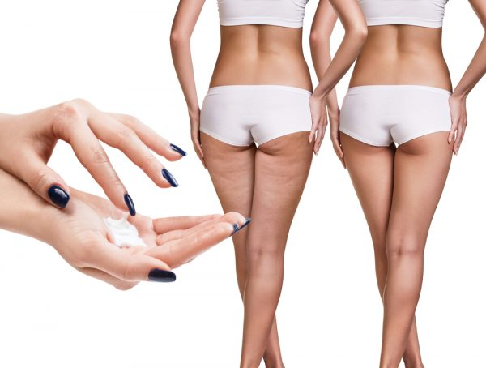

Cellulite Massage Special
  - we use our specially formulated cellulite cream
  - $250 for 3 visits and a jar of cream
  - [regularly $305]
  - Essential Balance, LLC
  - call today!
  - 302-861-6353

